Step 1: Select Cloud Formation

Image:



Step 2: Create Stack

Image:

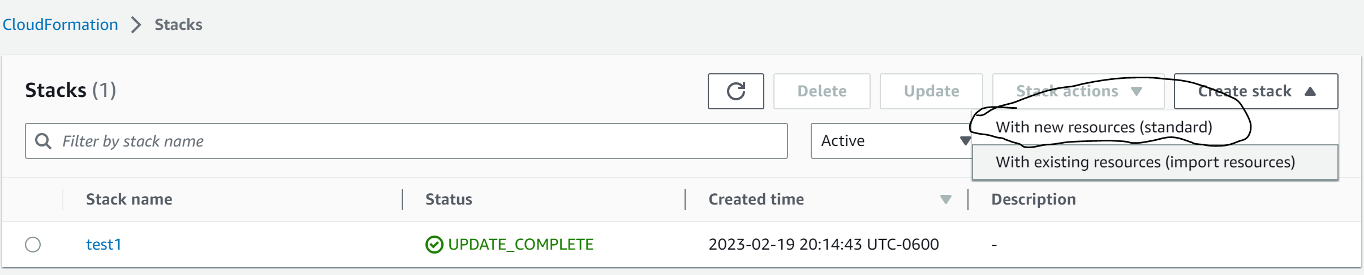

-

Step 3: Create a Designer Template and select create template in designer

Image:

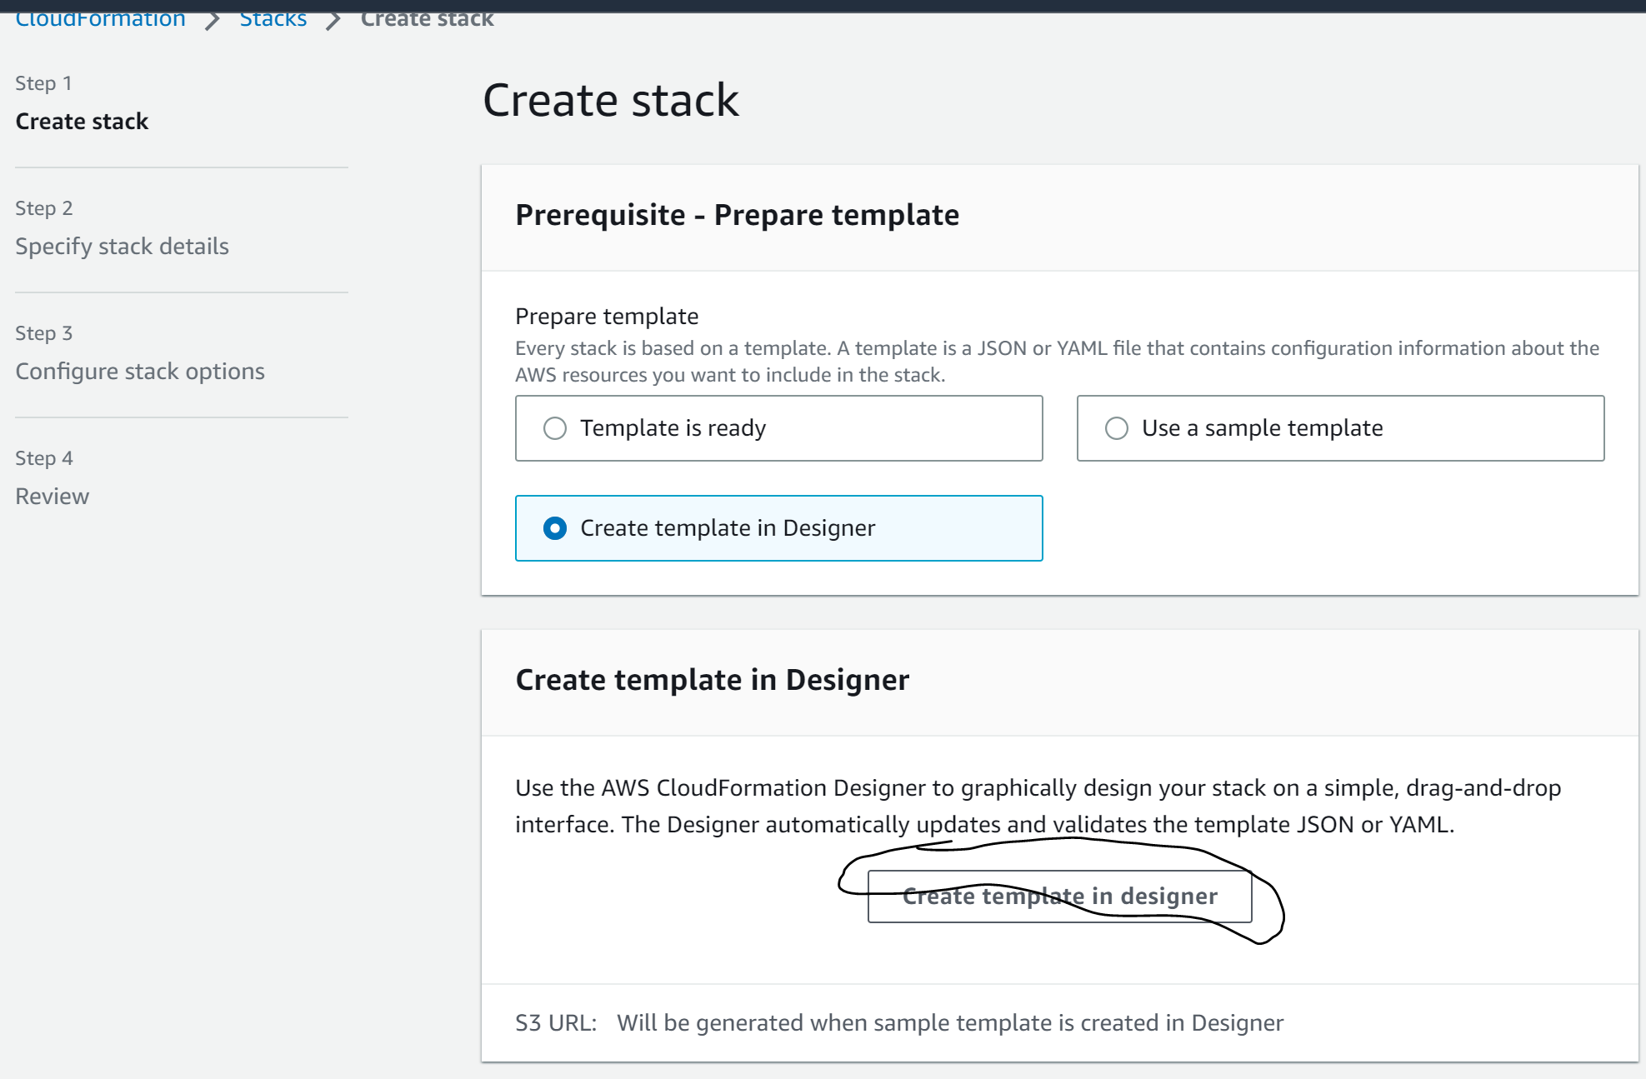

-

Step 4: Navigate to EC2

Image:

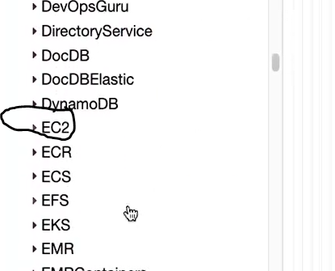

-

Step 5: Drag and drop EC2 instance

Image:

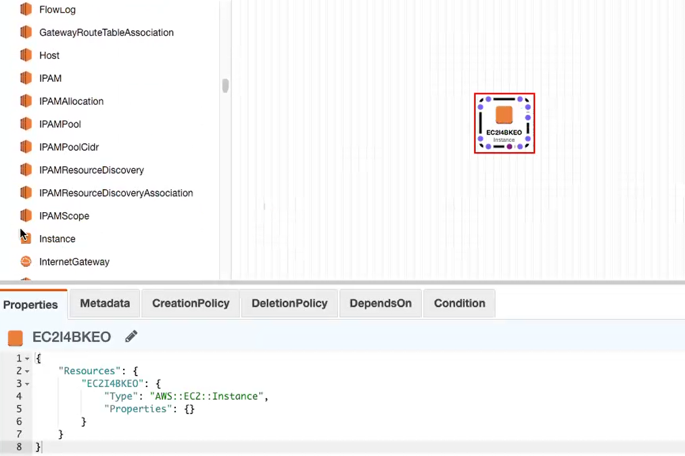

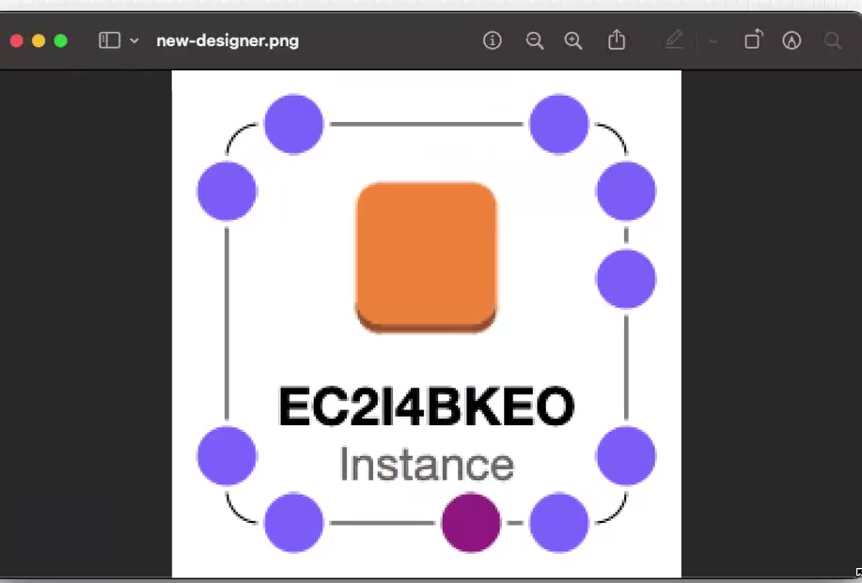

-

Step 6: Change format to YAML

Image:

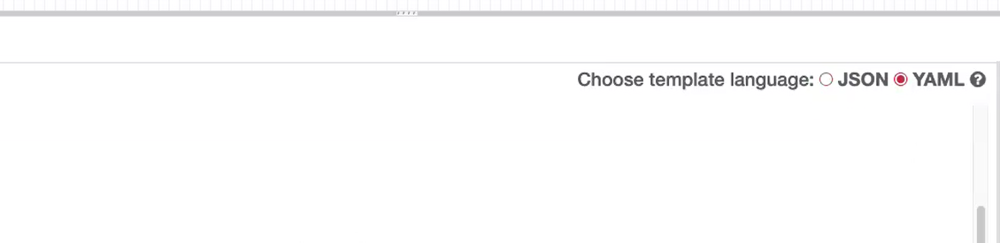

Step 7: Copy the cloud formation script into template(No User Data Included)

Image:

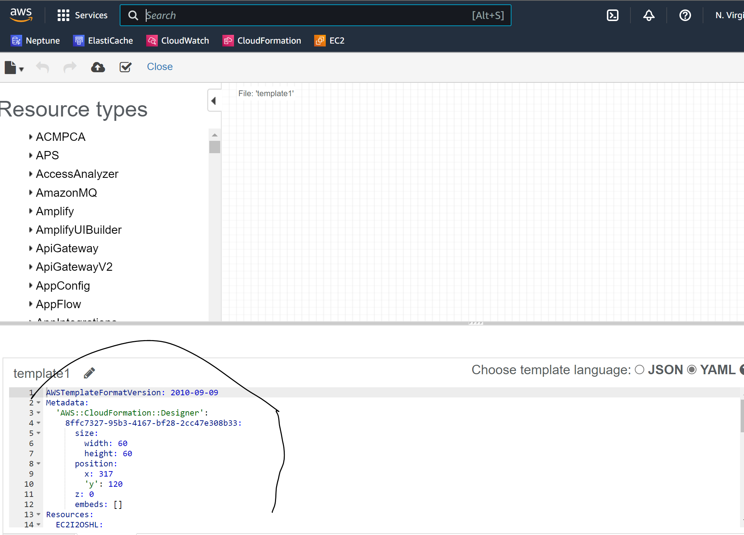

Step 8: Validate Template

Image:

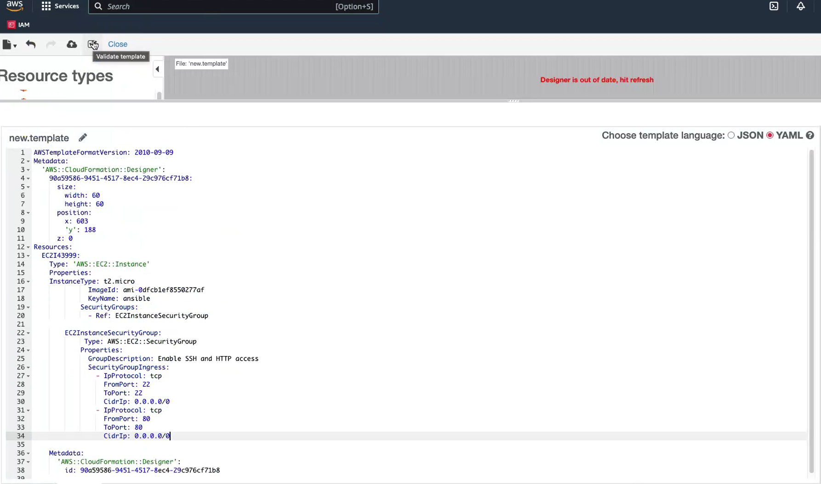

-

Step :

Image:

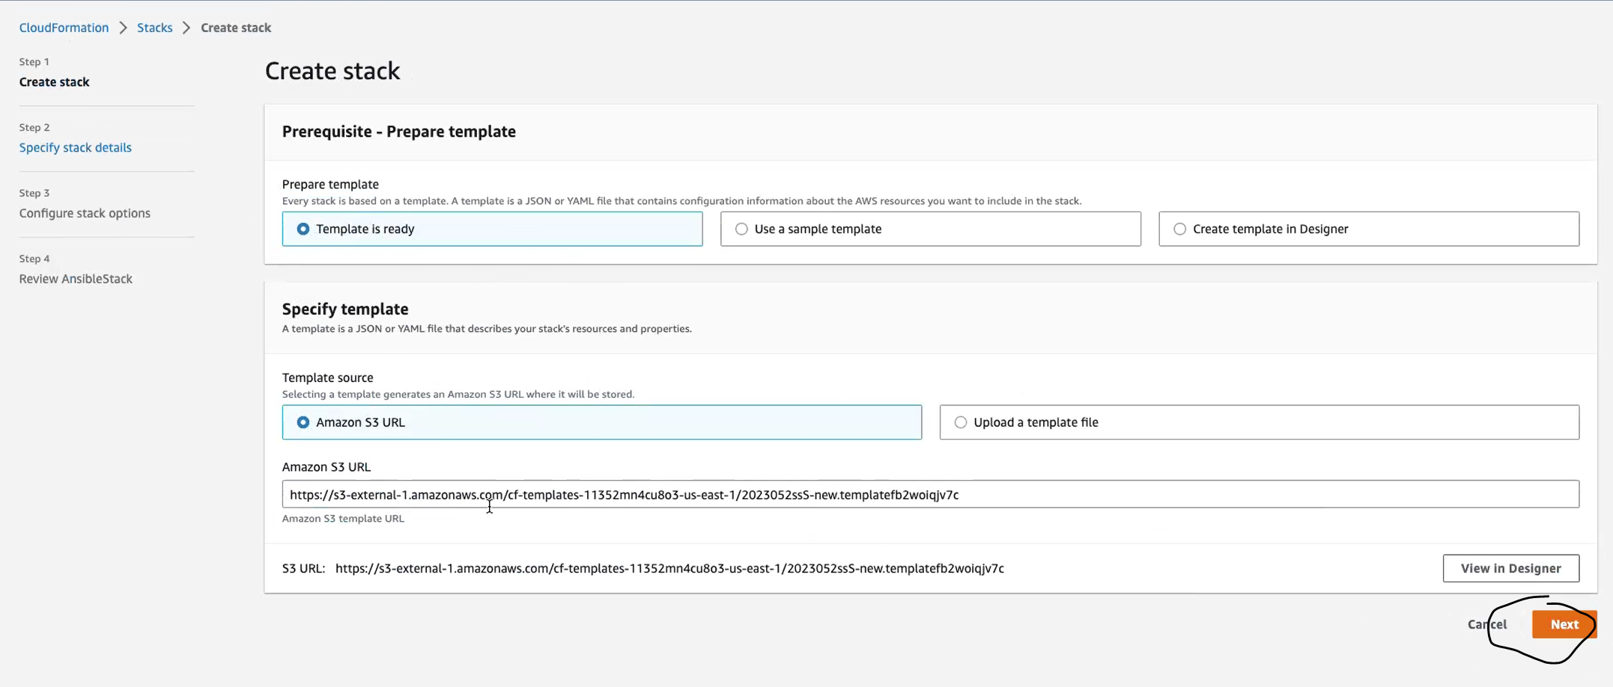

-

Step :

Image:

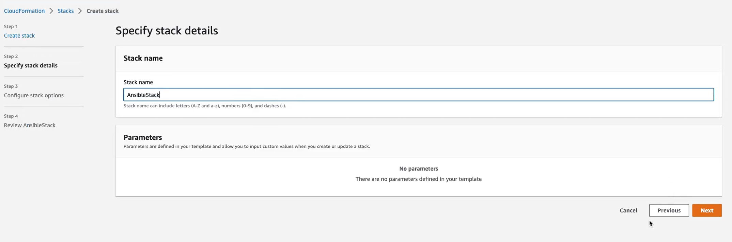

-

Step :

Image:

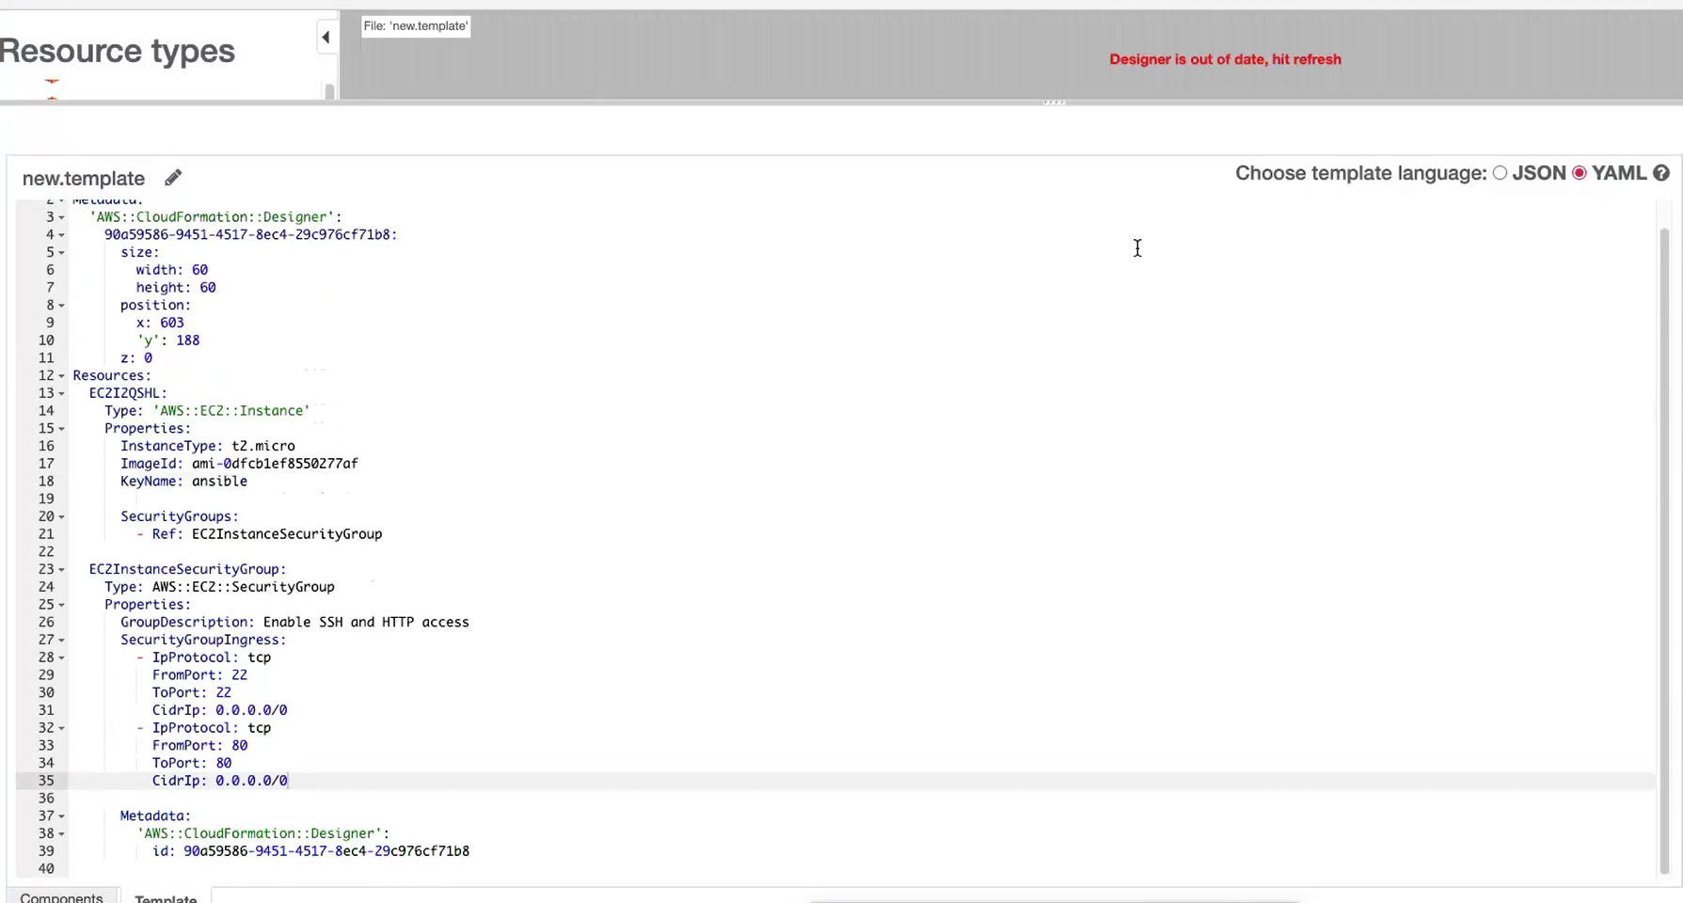

-

Step : Click Next

Image:

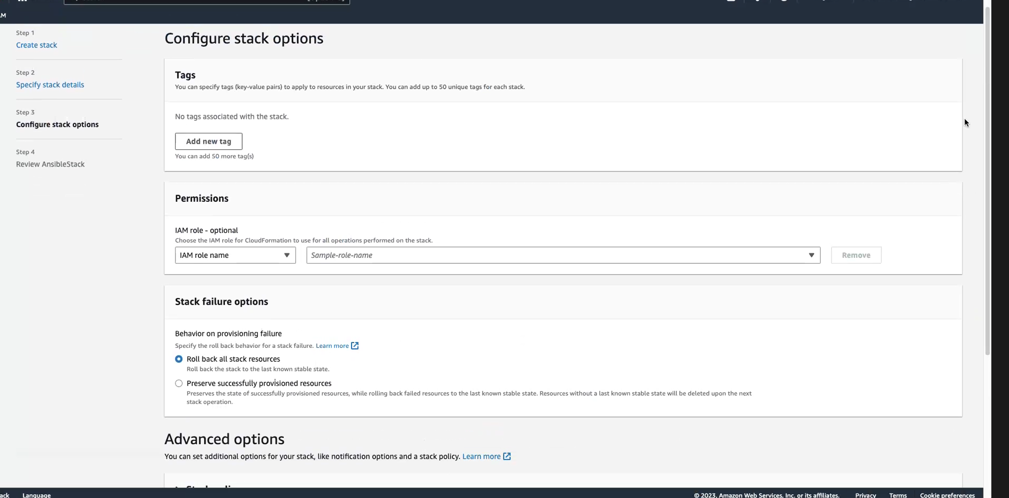

-

Step : Click on submit

Image: